Meno a priezvisko: ..................................................................... Trieda: ...................

1.Answer the questions about yourself

What animals do you like ? –

............................................................................
What animals don´t you like ?

........................................................................

2. Translate animals:

a snake................ a cow-.............. a frog-.................. a sheep- ............

a hippopotamus- ....................., a pig-............, a dophin-..............

an ostrich-................ , a kangaroo-..................., a bat- .................

medved-...........,opica-..................,lev-.............,krokodíl-.....................

slon-............, žirafa-...............,orol-................, žralok-....................

3.What are the animals doing? Choose from these verbs

Swim, run, fly,climb, sleep, drink, eat, jump......(present continuous)

Monkey is................. The kangaroo is.................

The bat is ..................... The dolphin is....................

The bear is.................. The elephant is................

The lion is............... The snake is.....................

Match the animals

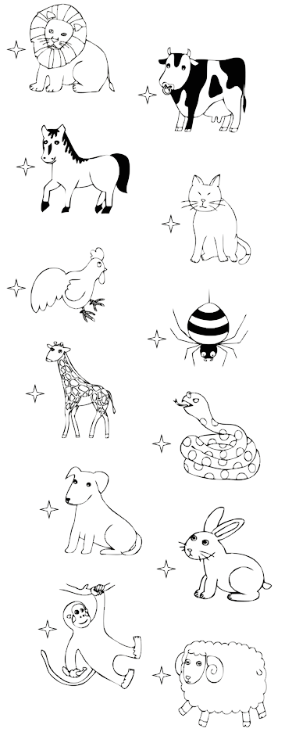
cat

cow

lion

Spider

giraffe

snake

dog

rabbit

monkey

chicken

Sheep

horse

